# Connecting to & Preparing Data

1. Which of the following is an example of metadata that can be managed in Tableau? Select all that apply.
   1. The data type of the data in the source database
   2. Which fields are hidden x
   3. The number of rows in the data
   4. The default aggregation for a field x

Renaming fields and changing the defaults for formatting or aggregation are metadata management tasks that can be handled in Tableau.

You can change the data type of a field in Tableau, but you cannot change the underlying data via metadata management… the data type and the number of rows in the data in the *source system* cannot be changed by Tableau. The documentation explains, “Changes that you make in the metadata area of the data source do not modify your underlying data.” <https://onlinehelp.tableau.com/current/pro/desktop/en-us/howto_connect.htm#manage-metadata>

1. Which file type can include an extract? Select all that apply.
   1. Data Source (.tds)
   2. Packaged Data Source (.tdsx)
   3. Packaged Workbooks (.twbx)
   4. Workbooks (.twb)

Data source files do not contain the actual data

Packaged data source files and packaged workbooks can both include extracts.

Workbook files can connect to extracts, but they do not themselves include extract.

[See this link for further info.](https://onlinehelp.tableau.com/current/pro/desktop/en-us/environ_filesandfolders.htm)

1. Which of the following is most likely to reduce the size of the extract?

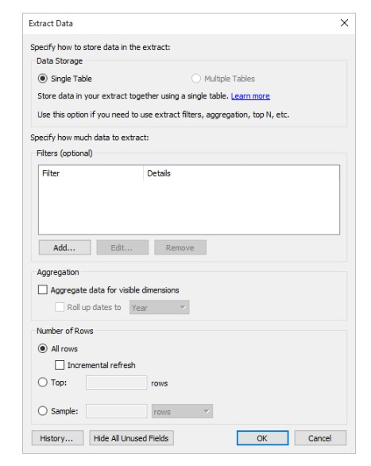

* 1. Selecting “Multiple Table” rather than “Single Tables”
  2. Using the incremental refresh option
  3. Materialize calculations with the “Compute Calculations Now” option
  4. Removing an filter

The Tableau documentation explains that the Multiple Tables option can potentially improve performance and help reduce the size of the extract file. When tables are joined, a new row is created each time the join criteria are satisfied, so that the resulting join can have many more rows than were in the original tables. In this case, storing the tables individually (using the Multiple Tables option) will take up less space.

Using the incremental refresh option should not impact the size of the extract – it should only impact whether the refresh works by removing the old extract completely and recreating it, or whether it adds new rows to the existing extract. [https://onlinehelp.tableau.com/current/pro/desktop/enus/extracting_refresh.htm#configure-an-incremental-extract-refresh](https://onlinehelp.tableau.com/current/pro/desktop/en-us/extracting_refresh.htm#configure-an-incremental-extract-refresh)

Materializing calculations may reduce the time to open the workbook since the results of the calculations will be saved in the extract, but will not reduce the workbook size.

[https://onlinehelp.tableau.com/current/pro/desktop/en-us/extracting_data.htm#about-the-computecalculations-now-option-for-extracts](https://onlinehelp.tableau.com/current/pro/desktop/en-us/extracting_data.htm#about-the-compute-calculations-now-option-for-extracts)

Removing a filter is likely to increase the size of the extract.

1. If a Tableau workbook does not include the fields *Latitude (generated)* and *Longitude (generated)* this indicates which of the following:
   1. The workbook does not include a map
   2. The workbook does not include any fields with a geographic role of state, city, country, or zip code
   3. The workbook does not include custom geocoding
   4. All locations are ambiguous or unknown

It doesn’t matter whether your workbook contains a map, *Latitude (generated)* and *Longitude*

*(generated)* are created when fields are assigned geographic roles. However, this will not happen if your data already has **non-generated** Longitude and Latitude. Here is an example:

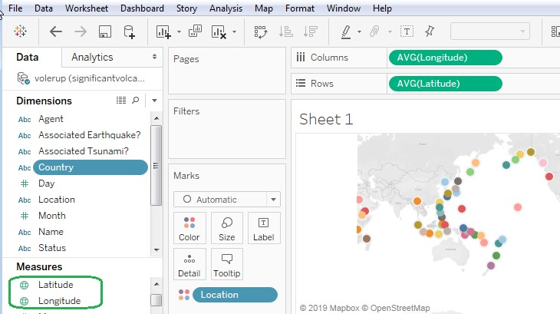

In this example, Latitude and Longitude are the only fields with geographic roles, and so, *Latitude (generated)* and *Longitude (generated)* do not appear. If we set a geographic role for Country, *Latitude (generated)* and *Longitude (generated)* will appear.

1. Union the Stocks 2010-2013 and Stocks 2014 tables, and then create a table showing the minimum value for Low stock price for each company in each quarter. Following Q2 of 2013, which company increased its minimum Low stock price for the most quarters in a row?
   1. Amazon, minimum low increased for five quarters in a row
   2. Biogen, minimum low increased for six quarters in a row
   3. Biogen, minimum low increased for five quarters in a row
   4. Apple, minimum low increased for six quarters in a row

Apple’s minimum low price increased for six consecutive quarters after Q2 of 2013:

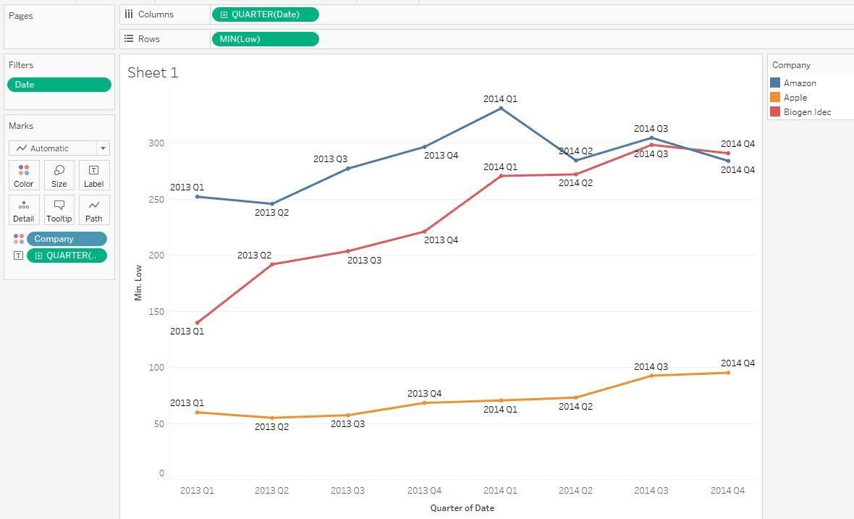

1. Blend the Southern Region table from the South_Superstore file with the Targets table from the South_Superstore file. Add subcategory, SUM(Sales) and Sales Target to the view. For which of the following subcategories did sales meet the target value? In other words, when was SUM([Sales]) greater than SUM([Sales Target])?
   1. Binders
   2. Bookcases
   3. Supplies
   4. Tables

Add both Southern Region and Targets:

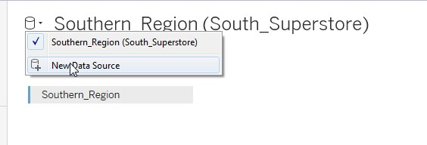

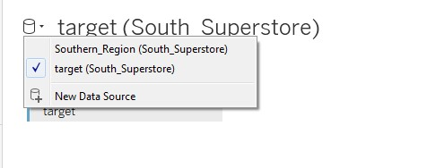

Create a new worksheet. If you try to add Sales from the SuperStore worksheet and Sales Target from the Target worksheet, you will get a warning popup saying that you need a relationship with the primary data source.

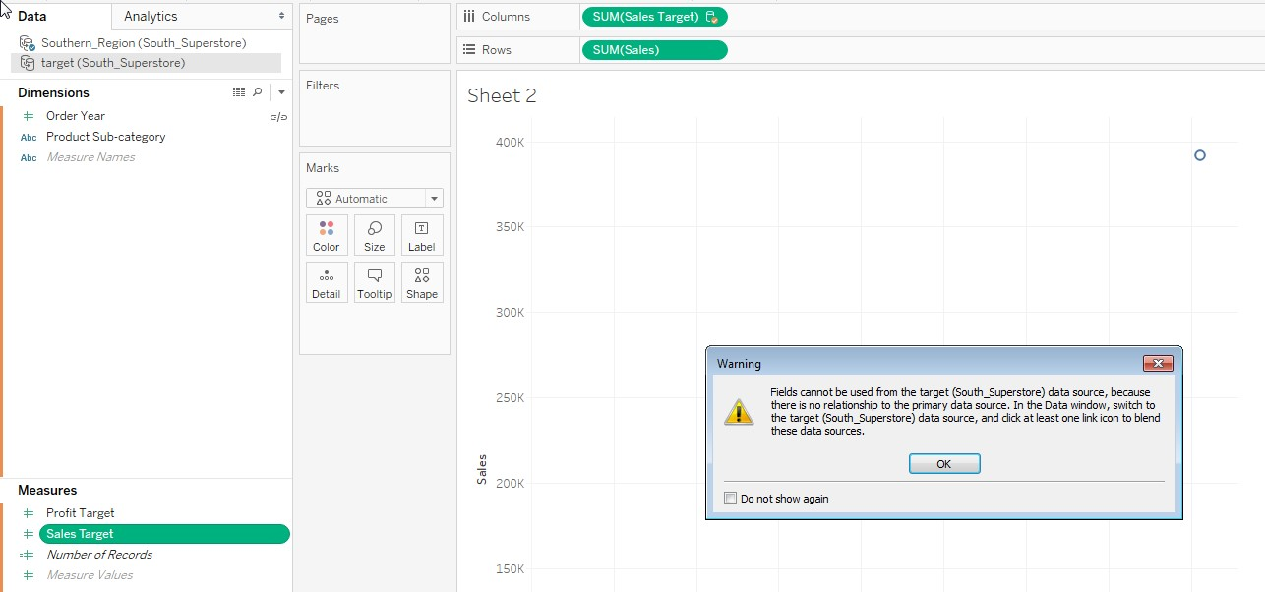

Set up the relationships as shown below:

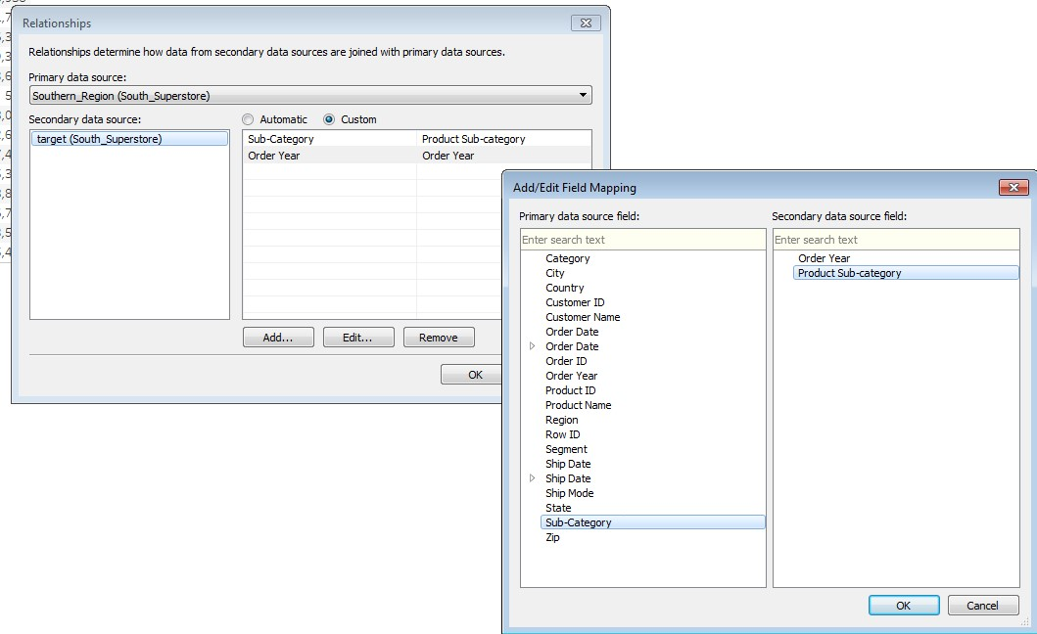

Check the results and notice that only Binders has a value that is higher than the target

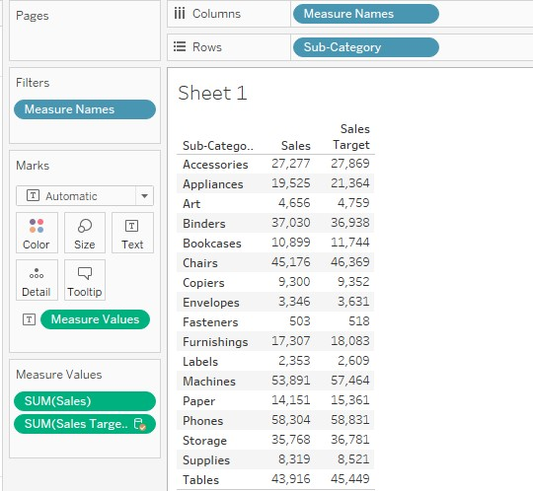

1. Create an inner join to combine the Southern Region worksheet with the Rewards customer worksheet. The join field should be Customer ID. What segment had the highest sales for rewards customers? Within that segment, which customer had the highest sales?
   1. Top segment is Home Office, and the top customer in that segment is Alejandro

Ballentine

* 1. Top segment is Consumer, and the top customer in that segment is Sanjit Engle
  2. Top segment is Corporate, and the top customer in that segment is Anna Häberlin
  3. Top segment is Consumer, and the top customer in that segment is Shahid Collister

Join the worksheets:

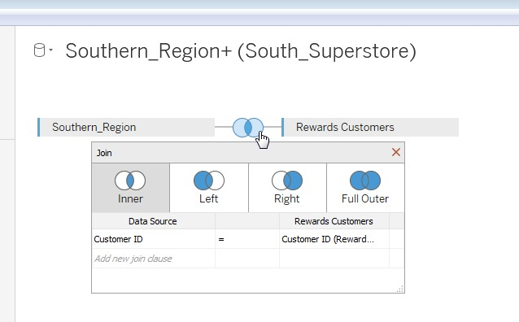

Create a hierarchy with segment and customer name

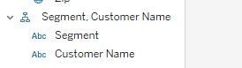

Add sales and segment. Consumer has the highest sales

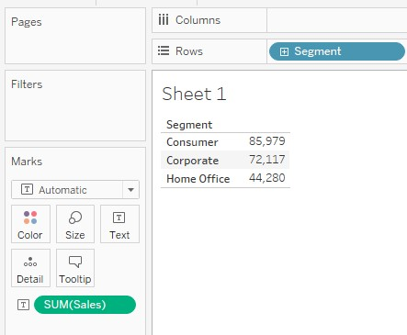

Expand the hierarchy

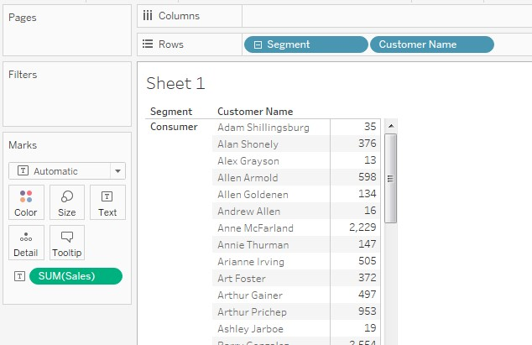

Nested sort

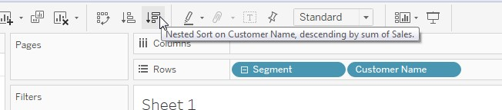

Shahid Collister is the rewards customer with the highest sales in the Consumer segment

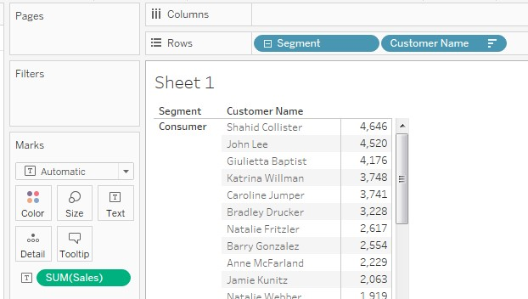

# Exploring & Analyzing Data

8. Which visualization always represents a measure using color?

1. Pie chart
2. Scatter plot
3. Combo chart
4. Highlight table

A highlight table is represents a measure using color. The other options may or may not use color to represent a measure.

<https://onlinehelp.tableau.com/current/pro/desktop/en-us/buildexamples_highlight.htm>

1. You would like to divide your customers into two categories – those with sales above a certain threshold and those with sales below that threshold. Which of the following tools will allow you to do this? Select all that apply.
   1. Hierarchy
   2. Parameter
   3. Set
   4. Calculation

You can do this with a set

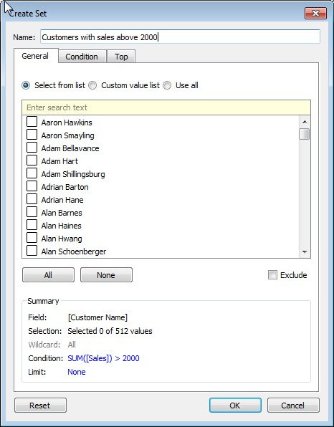

Or with a calculated field:

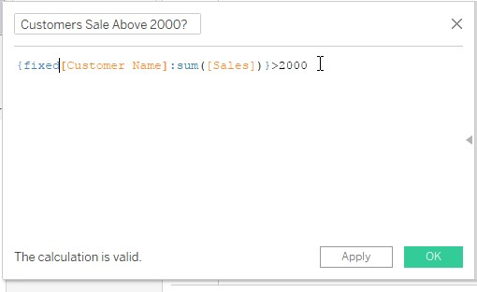

Simply adding a parameter will not change the view. You’d need to use the parameter as part of a calculation or filter to change the view. And a hierarchy will not help with this unless you already have a field that divides into those above or below 2000.

1. Which of the following does Tableau automatically put into a hierarchy?
   1. Date fields (year > month > day)
   2. Geographic fields (country > city > state)
   3. Field with field name containing the keyword “sub-” (product category, product subcategory)
   4. Numeric fields (Millions > Thousands > Ones)

The tableau documentation explains, “When you connect to a data source, Tableau automatically separates date fields into hierarchies so you can easily break down the viz. You can also create your own custom hierarchies. For example, if you have a set of fields named Region, State, and County, you can create a hierarchy from these fields so that you can quickly drill down between levels in the viz.” <https://onlinehelp.tableau.com/current/pro/desktop/en-us/qs_hierarchies.htm>

1. Which of the following can you use to create a calculated field that shows the change from the prior month total?
   1. An aggregate calculation
   2. A table calculation
   3. A basic calculation
   4. A subtraction calculation

A table calculation can show the difference between the current and prior month. First we have a view showing the total sales by month:

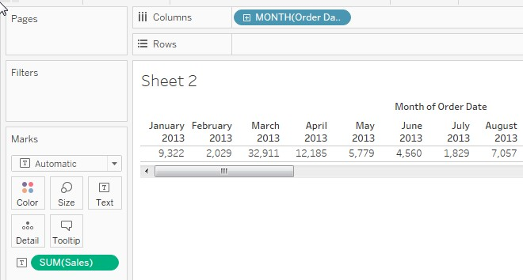

Then we add the table calculation to show difference from the prior month:

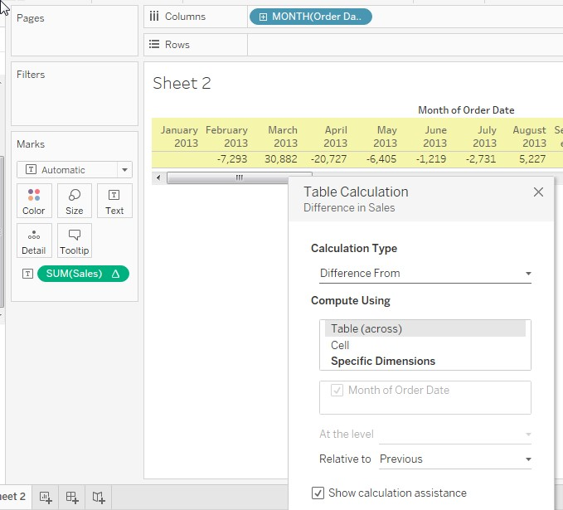

1. In which year or years is SUM(Profit) greater than SUM(Sales)?

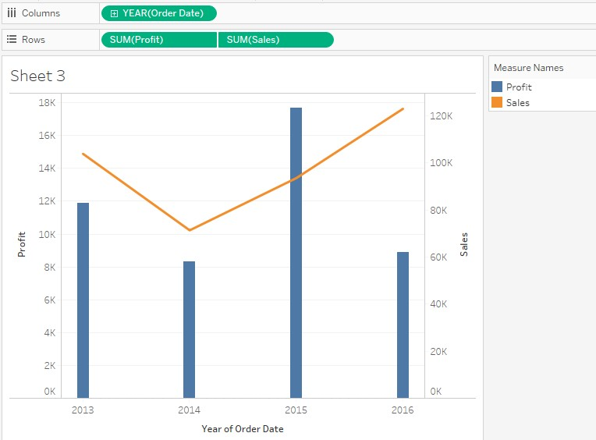

* 1. 2013, 2014, and 2016
  2. 2014
  3. All of the above
  4. None of the above

The two measures shown here are using different axes that are not synchronized. The axis for Sales is shown on the right side, while the axis for Profit is shown on the left side. SUM(Sales) is above 70K for all years shown, while SUM(Profit) is below 18K for all years shown.

1. The chart below has the value for one of the average reference lines highlighted in the tooltip, with a value of 19,883. What does this average line represent?

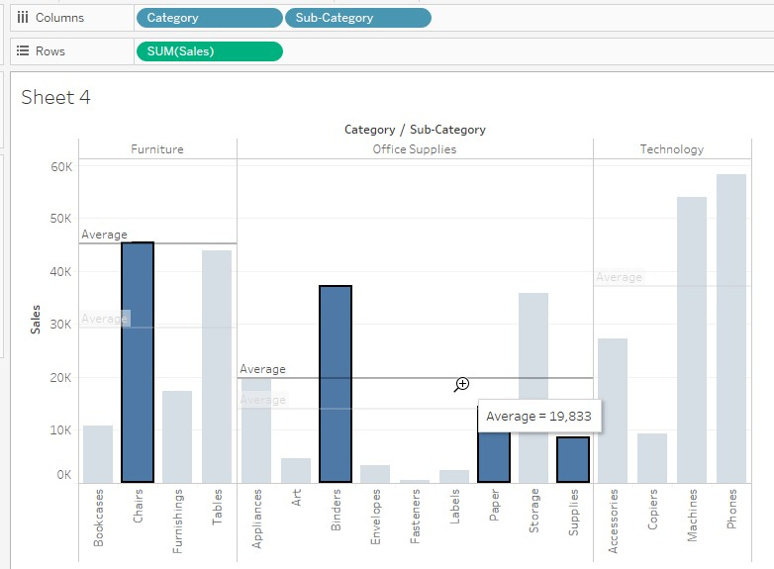

* 1. The average values of sales for all sub-categories in the office supplies category
  2. The average values of sales for all product categories
  3. The average values of sales for Binders, Paper, and Supplies
  4. The average values of sales for Binders, Paper, Supplies and Chairs

The reference line shows the average values of sales for the selected subcategories within the current pane, which in this case is Office Supplies. If you unselect Chairs you will notice the value does not change:

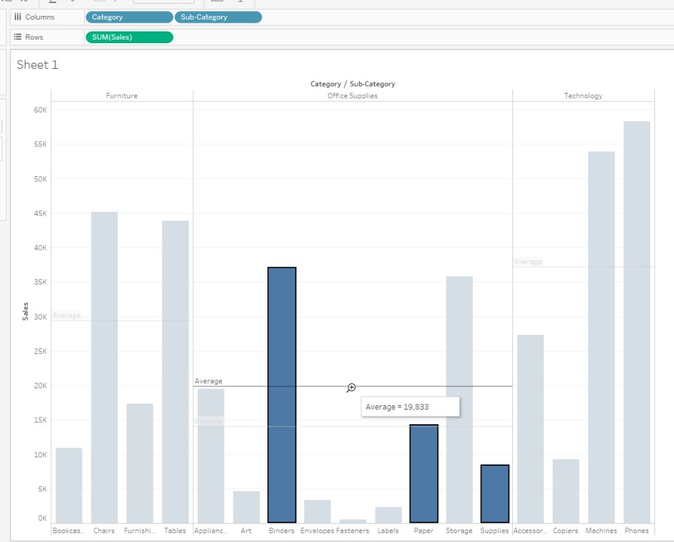

1. A histogram must include which of the following? (select all that Apply)
   1. Bin
   2. Dimension
   3. Count
   4. Count Distinct

A histogram always bins data and uses the COUNT (also shown as CNT) function to count the number of occurrences within the bin: <https://onlinehelp.tableau.com/current/pro/desktop/en-us/buildexamples_histogram.htm>

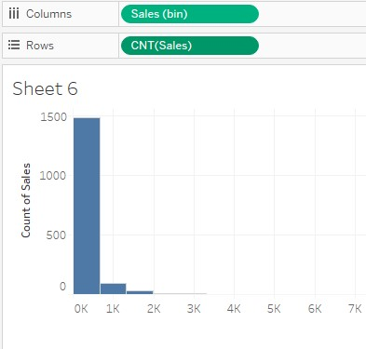

15. If you are creating a geographic map with cities, but some of the locations are showing as ambiguous, how might you correct this?

1. Add a field called “Street Name” to the view
2. Add *Latitude (generated)* and *Longitude (generated)* to the view.
3. Add a field called “State” to the view
4. In the Edit Locations dialog box, click on one of the Ambiguous cells to match a known location to your unknown data. When you click on an unrecognized cell, a search box appears. As you begin typing in the search box, Tableau generates a list of possible locations. Select a location from the list.

When you see that a city is ambiguous that means it exists in multiple states or countries, and so Talbeau doesn’t know which state or country to map it to. For example, there is a Rome in Italy, but also a less-well known city also called Rome, New York in the USA [https://en.wikipedia.org/wiki/Rome%2C_New_York.](https://en.wikipedia.org/wiki/Rome%2C_New_York)

Tableau does not map streets, so including street name will not resolve the ambiguity. Adding *Latitude (generated)* and *Longitude (generated)* will not resolve ambiguous locations because unless Tableau has more information it cannot determine which state or country the city should go in. Editing the location will help for misspelled or unrecognized locations, but not for ambiguous locations.

Adding State might resolve the ambiguity. For example, if the city is Rome and we add New York, Tableau will know that the city is not Rome in Italy but rather Rome in New York state. <https://onlinehelp.tableau.com/current/pro/desktop/en-us/maps_editlocation.htm>

Answer D is not correct because the Edit Location Dialog Box requires a latitude and longitude to resolve the ambiguity:

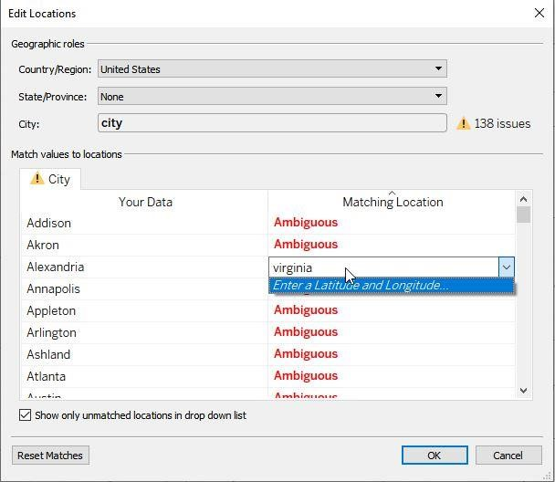

1. Using the Southern Region worksheet of the South SuperStore data, looking just at orders placed in 2014, what percent of the total sales comes from the Home Office segment? a. 5.67%
   1. 18.97%
   2. 25.37%
   3. 31.12%

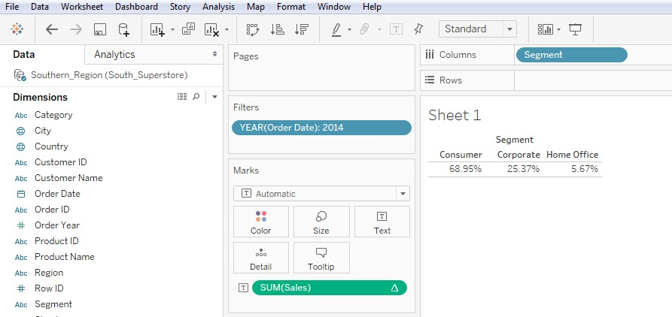

1. Using the Southern Region worksheet from the South Superstore file, find the top 10 products by sales in the home office segment. Which of the following products is in the top 10?
   1. Samsung Galaxy Mega 6.3
   2. GBC DocuBind TL300 Electric Binding System
   3. Iceberg Mobile Mega Data/Printer Cart
   4. Cubify CubeX 3D Printer Triple Head Print

Create set:

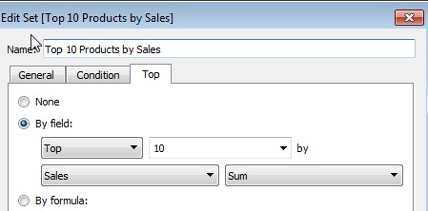

Use the set as a filter.

Add Home Office as a filter, and add it to the context so that the filter executes before the set. Setting “Segment: Home office” as a context filter means that Tableau will *first* limit the data to Home Office, and then find the top 10 products by sales.

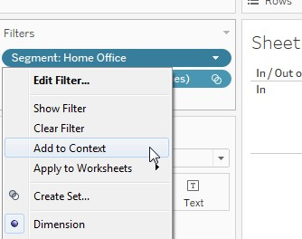

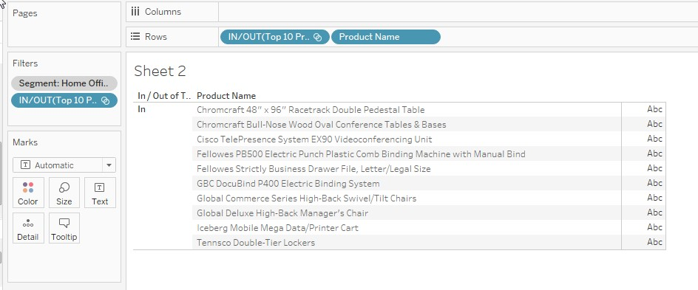

1. Using the Southern Region data on the South Superstore file, create a histogram showing the number of Sales using Sales Bins of $500. Which bins have negative total profit? (Select all that apply)
   1. 0
   2. 500
   3. 1000
   4. 1500
   5. 2000
   6. 2500
   7. 3000
   8. 3500
   9. 4000

Create histogram with profit

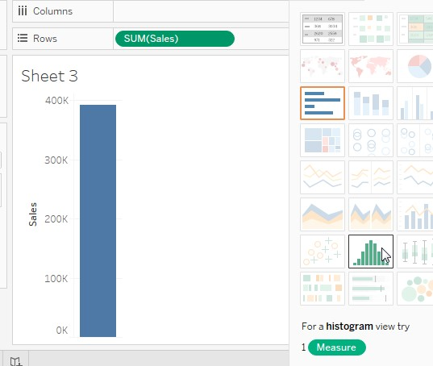

Set the bin size:

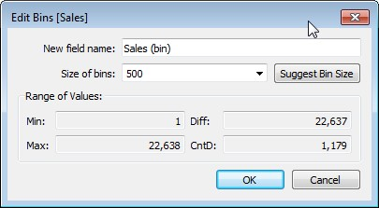

Drag SUM(Profit) to Color:

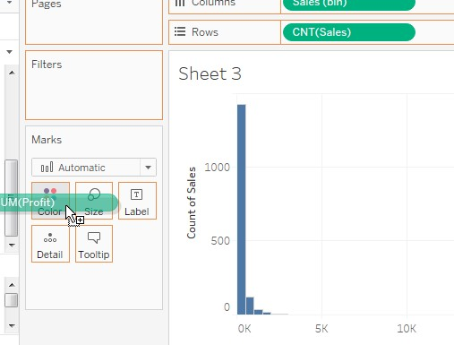

Mouse over the bins to see which have negative profit

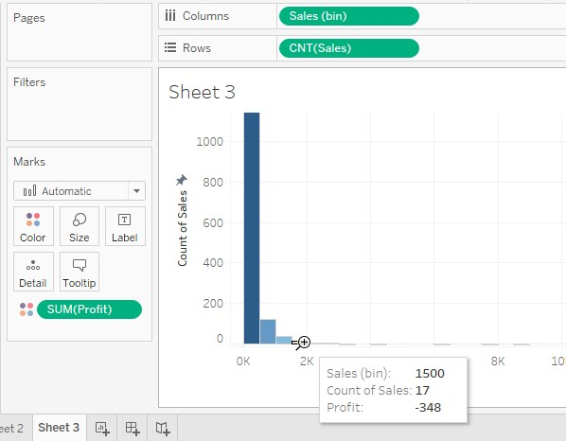

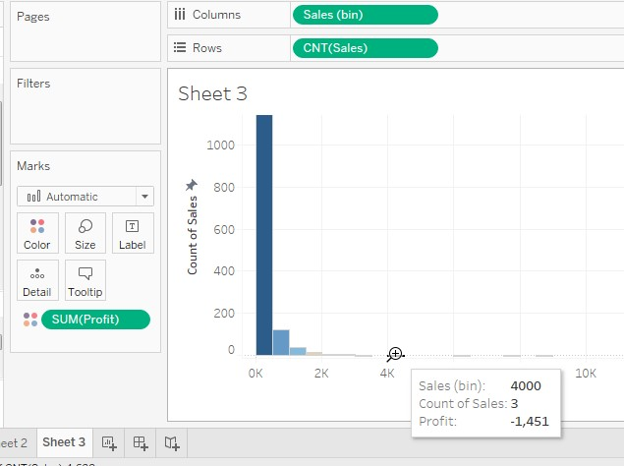

# Sharing Insights

1. Your view has a histogram showing the distribution of Sales. You’d like to use a color gradient to shade the bars according to the value of Profit. You drag profit to the color mark. How would you adjust the colors so that all negative values are shown in one color and all positive values are shown in a second color?
   1. Click the colors mark, select edit colors, and check center on zero and switch the dropdown from continuous to discrete color gradient.
   2. Click on the quantitative legend and select format legend. Select a diverging palette and stepped color.
   3. Click the arrow on the colors mark, select edit colors, select a diverging palette from the dropdown and check stepped color with 2 steps and check center on zero.
   4. Click the colors mark, switch to a palette with two colors and check discrete color.

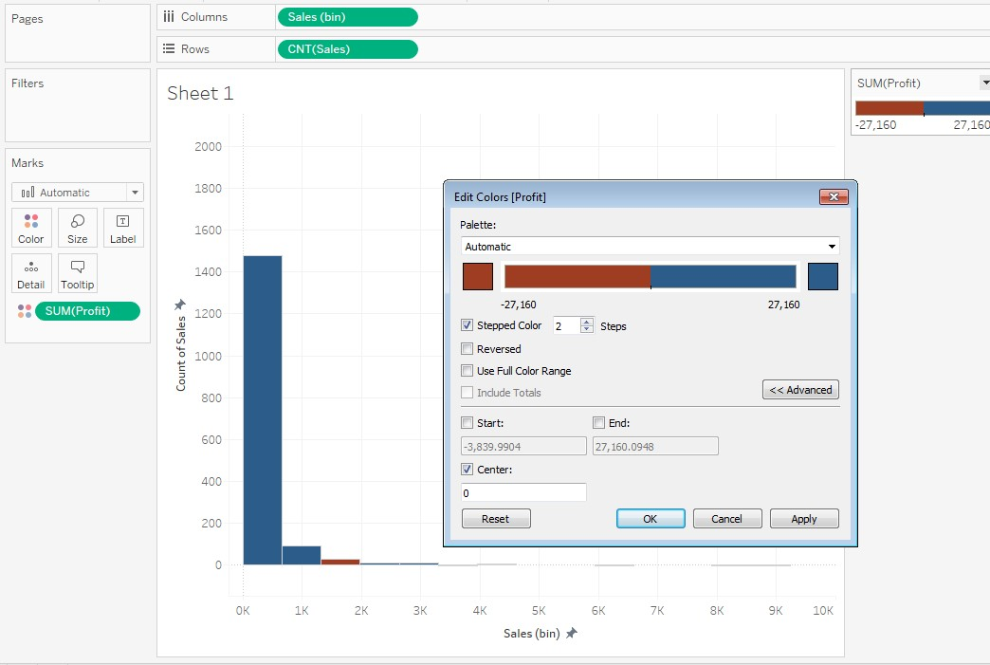

1. For which of the following is it *not* possible to adjust the size of the marks?
   1. Bar chart
   2. Tree map
   3. Pie chart
   4. Heat maps

Try adjusting size on a tree map and you will see it is not an option:

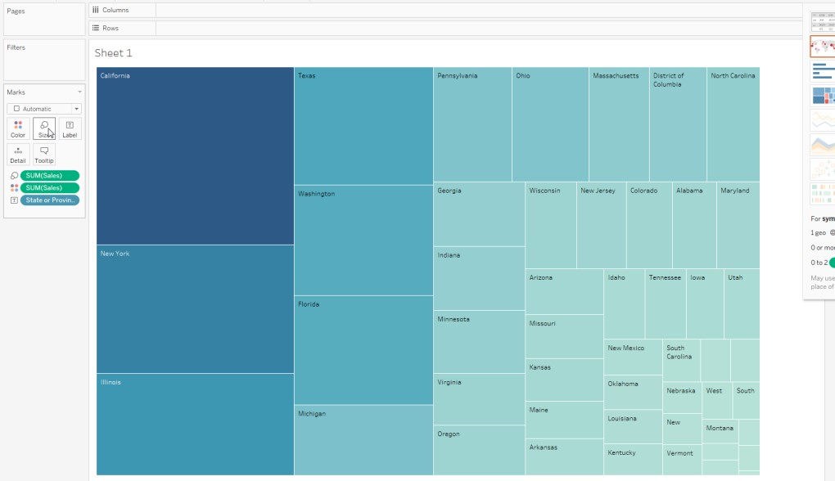

If you look at the other visualizations listed, you will see that you can edit the mark size:

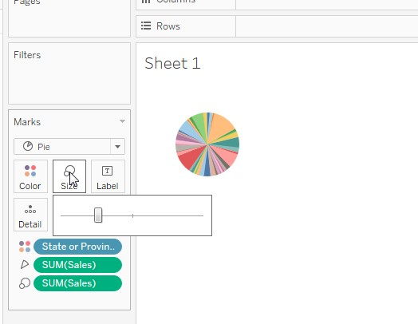

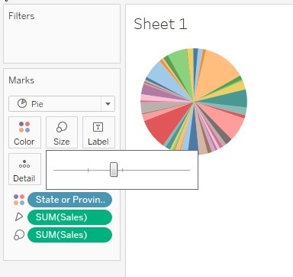

1. Editing the font at the worksheet level applies the changes you make to all text fields in view except for which of the following? (select all that apply)
   1. Header
   2. Axis
   3. Caption
   4. Tooltip

Editing the font at the worksheet level applies the changes you make to all text fields in view except the Tooltip fields. Try it yourself to confirm, and also look at the example below where I’ve changed the font for the workbook but the tooltip is unchanged.

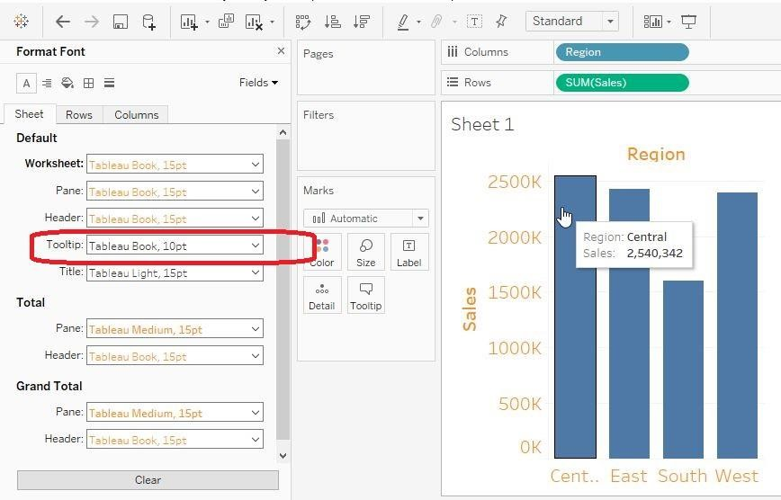

If you want to change the tooltip, you need to set the font using the highlighted box or click on the tooltip card and edit:

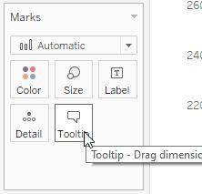

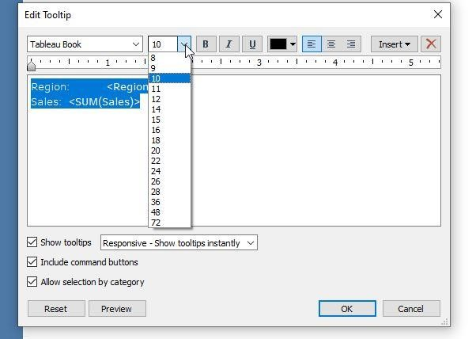

1. You have a dashboard containing multiple worksheets. One of the worksheets in the dashboard has a scroll bar. Which of the following steps can you take to remove the scroll bar?

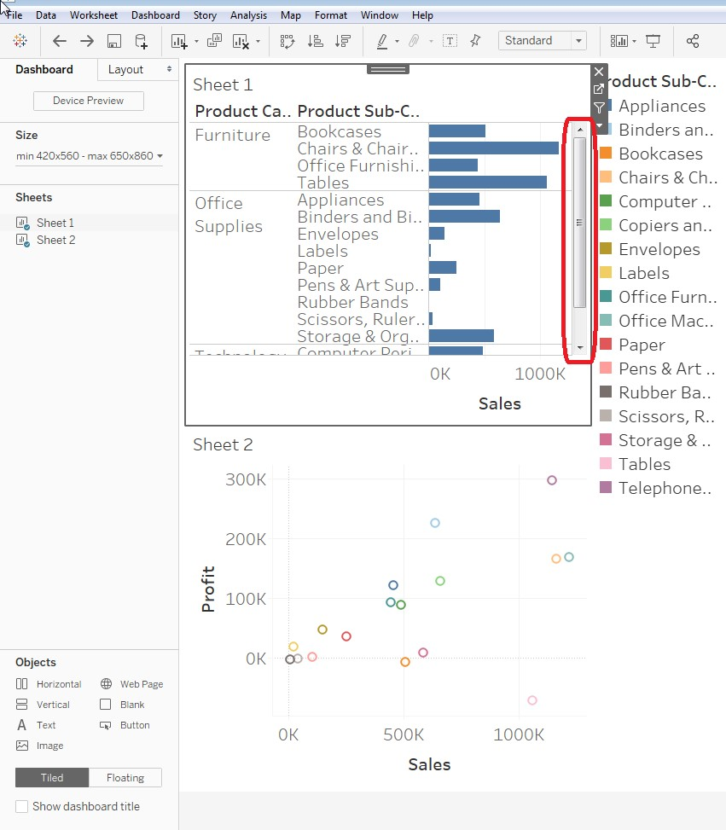

* 1. Right click on the scroll bar and select remove.
  2. Click the more options arrow, select fit, and select fit height.
  3. Click the more options arrow, select font, and use the dropdown to decrease the font size to reduce the size of the worksheet.
  4. Right click on the worksheet name on the dashboard pane, select fit, and then select entire view.

There is no “remove” option, so choice “a is not correct.

If you try “fit height” you will see that this adjusts the size so that the scrollbar no longer shows.

1. Which of the following describes the layout of the dashboard below?

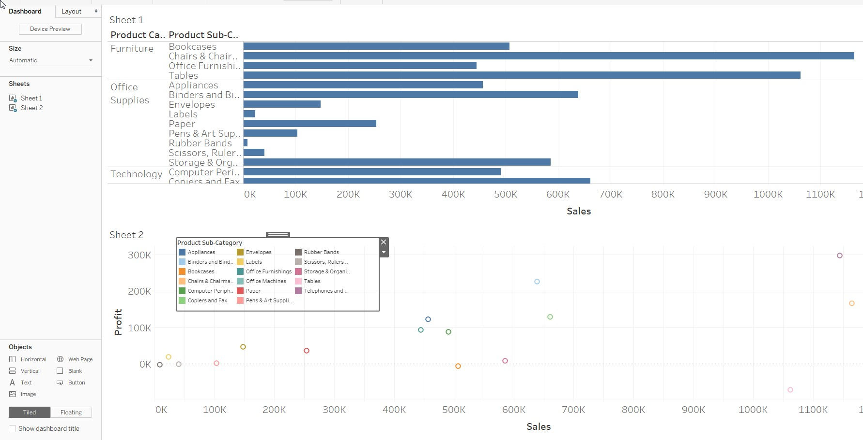 a. Tiled layout with the legend floating

* 1. Floating layout with the legend tiled
  2. Floating layout for all elements
  3. Tiled layout for all elements

The legend is overlapping the Profit worksheets, which is only possible because it is set as floating.

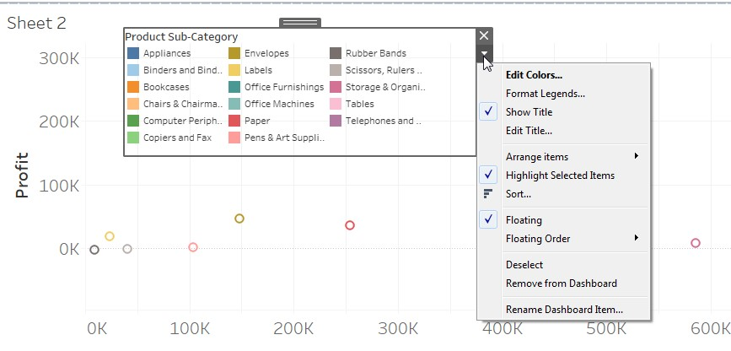

However, the layout of the dashboard overall is set to tiled. You can see this because the Tiled button is selected.

# Understanding Tableau Concepts

1. If you drag a field called Sales to the filter area, and you do not get a menu like the one shown below, but are immediately taken to the filter menu, what does this indicate about Sales?

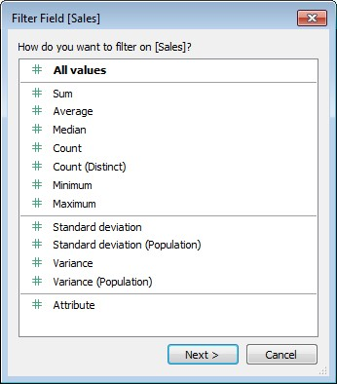

* 1. It is set as a measure
  2. It is set as a dimension
  3. It is set as discrete
  4. It is set as continuous

But if it is set as a dimension, you will be taken immediately to a filter menu. If Sales is a discrete dimension, the filter menu will look like this:

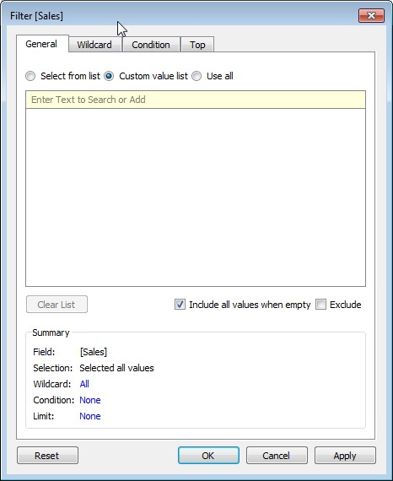

If it is a continuous dimension, the filter menu will look like this:

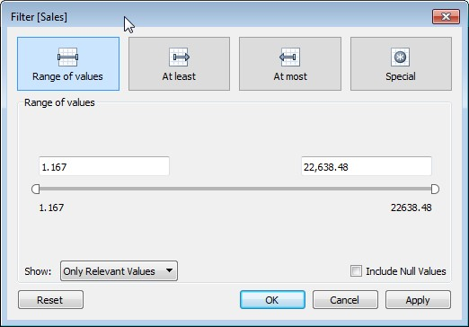

But in either case, if the field is set as a dimension then you only have the option to filter on the rowlevel values, not on the aggregated values.

1. In this view, which field is continuous and which is discrete?

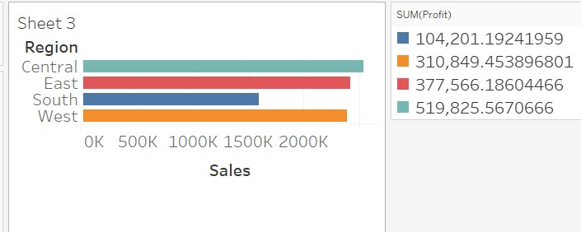

* 1. Sales is discrete and Profit is discrete
  2. Sales is continuous and Profit is discrete
  3. Sales is discrete and Profit is continuous
  4. Sales is continuous and Profit is continuous

Profit has a color

1. A line chart is broken into separate sections by year. What does this indicate about the date used in the line chart?
   1. The date is a continuous dimension
   2. The date is a continuous measure
   3. The date is a discrete measure
   4. The date is a discrete dimension

Here is an example with date as a discrete dimension:

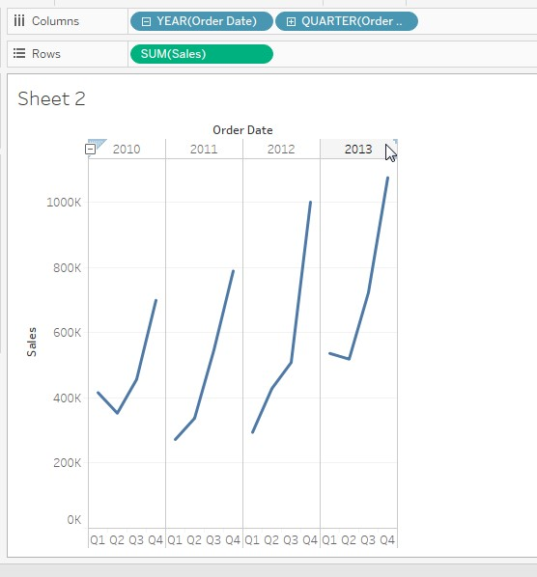

Also, in the show me menu you see that lines (discrete) are divided, while lines (continuous) are not divided:

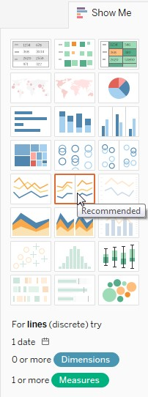

1. Which of the following will increase the granularity of the view?
   1. Adding a dimension to the marks area
   2. Adding a measure to the marks area
   3. Adding a dimension as a filter
   4. Adding a measures as a filter

Adding a dimension to the marks area will increase the granularity of the view

1. Profit and Sales are continuous measures in the workbook. Order ID is a dimension. Which of the following will most likely not have further aggregation applied when it is added to the view?
   1. {FIXED [Order ID] : max([Sales])}
   2. SUM([Sales])
   3. [Sales] – [Profit]
   4. Year([Order Date])

{FIXED [Order ID] : max([Sales])} is a level of detail calculation, and so it is not yet aggregated

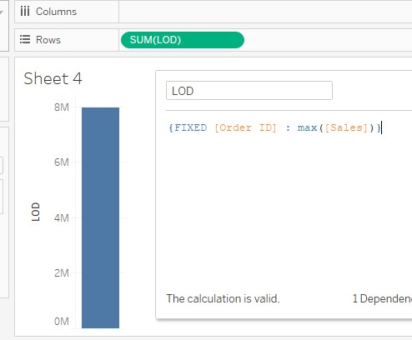

The calculated field Year([Order Date]) will by default be a measure, so it will be aggregated when added to the view.

SUM([Sales]) is already aggregated, so it will not be further aggregated when added to the view. Instead Tableau will use AGG([Field Name]) to represent the fact that the field is already aggregated:

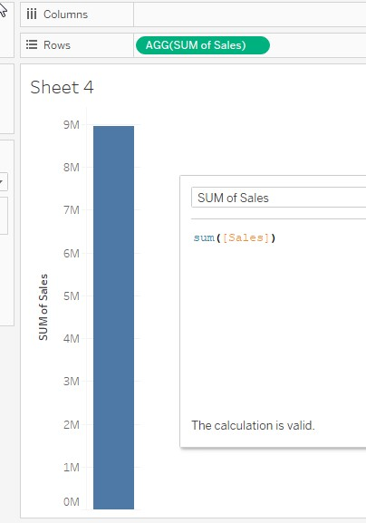

The calculated field [Sales] – [Profit] is a measure, but is not yet aggregated. It will be aggregated when it is added to the view.

1. Your view has a numeric field set as a discrete measure and a dimension. Which of the following visualizations can you create with these fields? (select all that apply)
   1. Line chart
   2. Text tables
   3. Highlight table
   4. Histogram

Because you have a discrete measure rather than a continuous measure, the visualizations available are more limited. The only option that is not greyed out it text table:

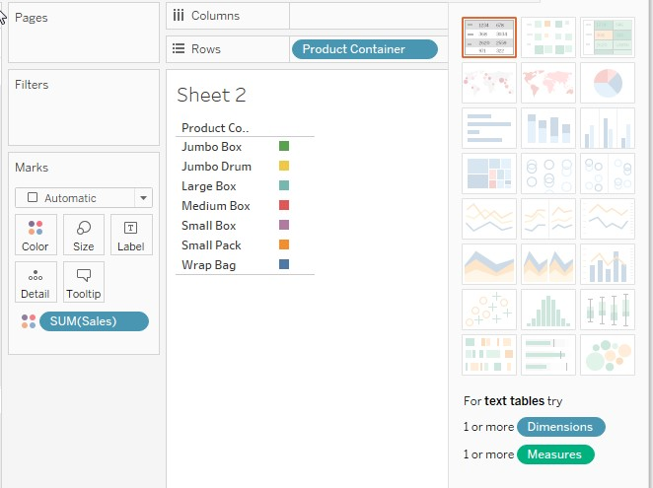

1. Which of the following fields is most likely to be a dimension?
   1. Unique Order Count
   2. Sales (bin)
   3. Sales
   4. *Measure Values*

The Tableau documentation explains, “When you create bins from a measure you create a new

dimension” <https://help.tableau.com/current/pro/desktop/en-us/calculations_bins.htm>

